**Practical No.1**

**Program 1:**

**Aim:** Program to blink Arduino onboard LED and To interface external LED with Arduino and write a program to turn ON LED for 1 sec after every 2 seconds.

**Objective of the program:** program to turn ON LED for 1 sec after every 2 seconds.

**Circuit design of program:**

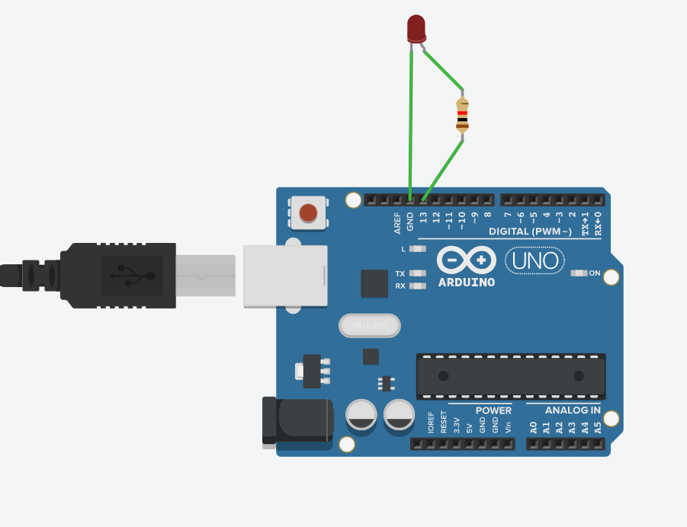

**Code:**

// C++ code

//

void setup()

{

pinMode(13, OUTPUT);

}

void loop()

{

digitalWrite(13, HIGH);

delay(1000); // Wait for 1000 millisecond(s)

digitalWrite(13, LOW);

delay(2000); // Wait for 2000 millisecond(s)

}

**Program 2:**

**Aim:** Program to blink Arduino onboard two LED and two resistor To interface external LED with Arduino and write a program to turn ON LED for 1 sec after every 2 seconds.

**Objective of the program:** Program to blink Arduino onboard two LED and two resistor to turn ON LED for 1 sec after every 2 seconds.

**Circuit design of program:**

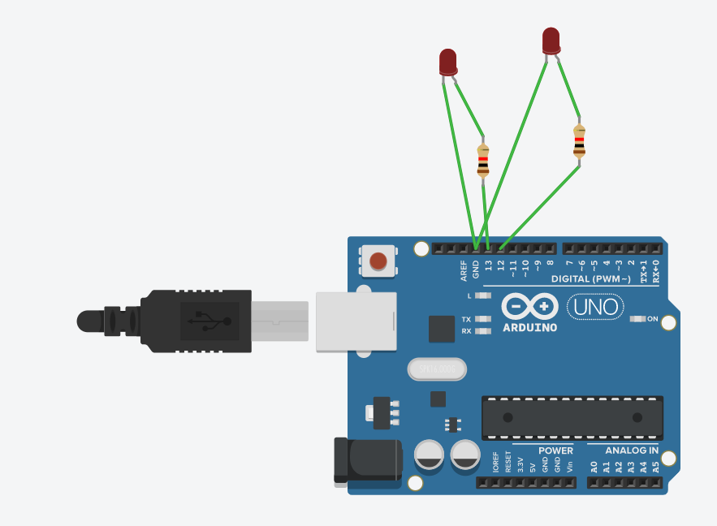

**Code:**

// C++ code

//

void setup()

{

pinMode(13, OUTPUT);

pinMode(12,OUTPUT);

}

void loop()

{

digitalWrite(13, HIGH);

digitalWrite(12,HIGH);

delay(1000);

digitalWrite(13, LOW);

digitalWrite(12,LOW);

delay(2000); // Wait for 1000 millisecond(s)

}

**Program 3**

**Aim:** Program to blink Arduino onboard two LED and one resistor To interface external LED with Arduino and write a program to turn ON LED for 1 sec after every 2 seconds.

**Objective of the program:** Program to blink Arduino onboard two LED and one resistor to turn ON LED for 1 sec after every 2 seconds.

**Circuit design of program:**

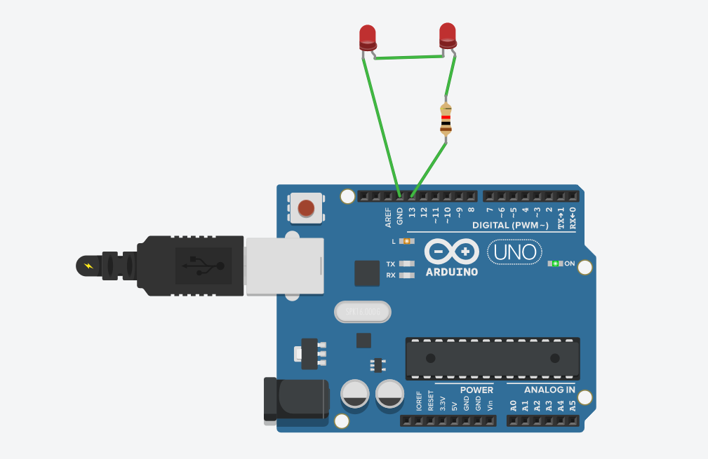

**Code:**

// C++ code

//

void setup()

{

pinMode(13, OUTPUT);

}

void loop()

{

digitalWrite(13, HIGH);

delay(1000); // Wait for 1000 millisecond(s)

digitalWrite(13, LOW);

delay(2000); // Wait for 1000 millisecond(s)

}

**Practical No.2**

# Aim: To interface 5 LED‟s with Arduino and write a program to blink 6 LEDs, one at a time, in a back and forth formation.

# Objective of the program: To interface 5 LED‟s with Arduino and write a program to blink 6 LEDs.

**Circuit design of program:**

# 

**Code:**

# void setup()

# {

# pinMode(13, OUTPUT);

# pinMode(12, OUTPUT);

# pinMode(11, OUTPUT);

# pinMode(10, OUTPUT);

# pinMode(9, OUTPUT);

# }

# void loop()

# {

# digitalWrite(13, HIGH);

# delay(1000);

# digitalWrite(13, LOW);

# delay(1000);

# digitalWrite(12, HIGH);

# delay(1000);

# digitalWrite(12, LOW);

# delay(1000);

# digitalWrite(11, HIGH);

# delay(1000);

# digitalWrite(11, LOW);

# delay(1000);

# digitalWrite(10, HIGH);

# delay(1000);

# digitalWrite(10, LOW);

# delay(1000);

# digitalWrite(9, HIGH);

# delay(1000);

# digitalWrite(9, LOW);

# delay(1000);

# 

# }

**Practical No.3**

# Aim: To interface Push button with Arduino and write a program to turn ON LED when push button is pressed.

# Objective of the program: To interface Push button with Arduino and write a program to turn ON LED when push button is pressed.

**Circuit design of program:**

# 

**Code:**

void setup()

# {

# pinMode(2,INPUT);

# pinMode(13,OUTPUT);

# }

# void loop()

# {

# if(digitalRead(2)==1)

# {

# digitalWrite(13,HIGH);

# }

# else

# {

# digitalWrite(13,LOW);

# }

# }

**Practical No.4**

**Aim:** To interface Push button, Speaker/buzzer with Arduino and write a program to turn ON LED and generate a note or tone when push button is pressed.

**Objective of the program:** Speaker/buzzer with Arduino and to turn ON LED and generate a note when push button is pressed.

**Circuit design of program:**

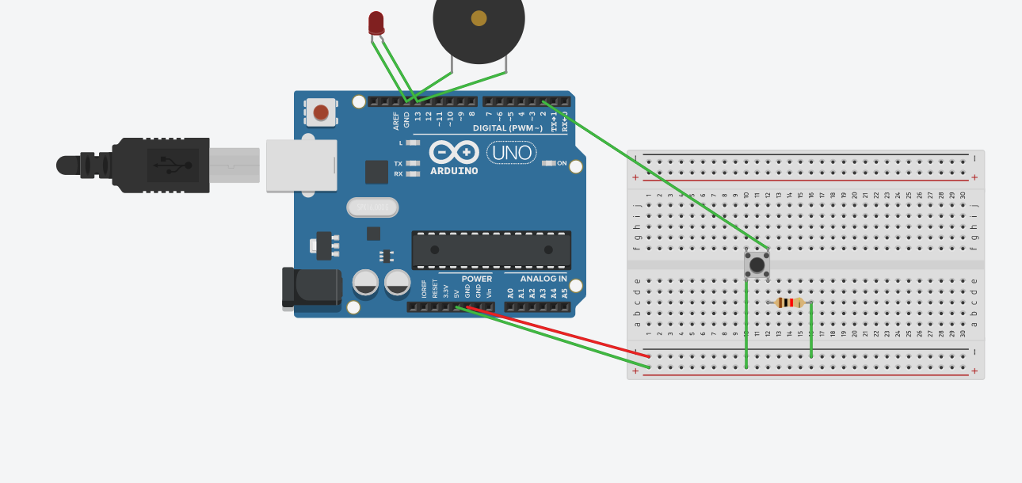

**Code:**

// C++ code

//

void setup()

{

pinMode(2,INPUT);

pinMode(13,OUTPUT);

}

void loop()

{

if(digitalRead(2)==1)

{

digitalWrite(13,HIGH);

}

else

{

digitalWrite(13,LOW);

}

}

**Practical No.5**

**Aim:** To interface 2 Push buttons, a Speaker with Arduino and write a program to turn  
ON LED and generate a 2 different tones on two button keyboard.

**Objective of the program:** To interface 2 Push buttons, a Speaker with Arduino and turn ON LED and generate a 2 different tones on two button keyboard.

**Circuit design of program:**

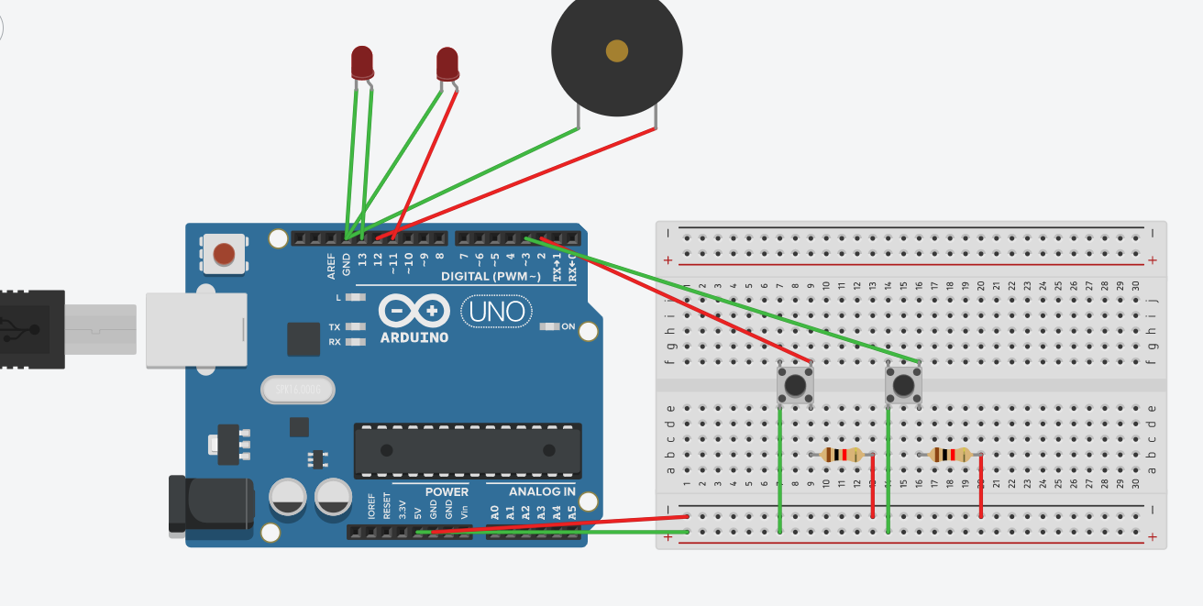

**Code:**

void setup()

{

pinMode(2,INPUT);

pinMode(3,INPUT);

pinMode(13,OUTPUT);

pinMode(12,OUTPUT);

}

void loop()

{

if(digitalRead(2)==1)

{

digitalWrite(13, HIGH);

digitalWrite(12, HIGH);

}

else if(digitalRead(3)==1)

{

digitalWrite(12, HIGH);

digitalWrite(11, HIGH); }

else

{

digitalWrite(13, LOW);

digitalWrite(12, LOW);

digitalWrite(11,LOW);

}

}

**Practical No.6**

**Program 1:**

**Aim:** To interface Seven Segment Display (SSD) with Arduino and write a program to blink SSD.

**Objective of the program:** Blinking of seven segment display using Arduino circuit.

**Circuit design of program:**

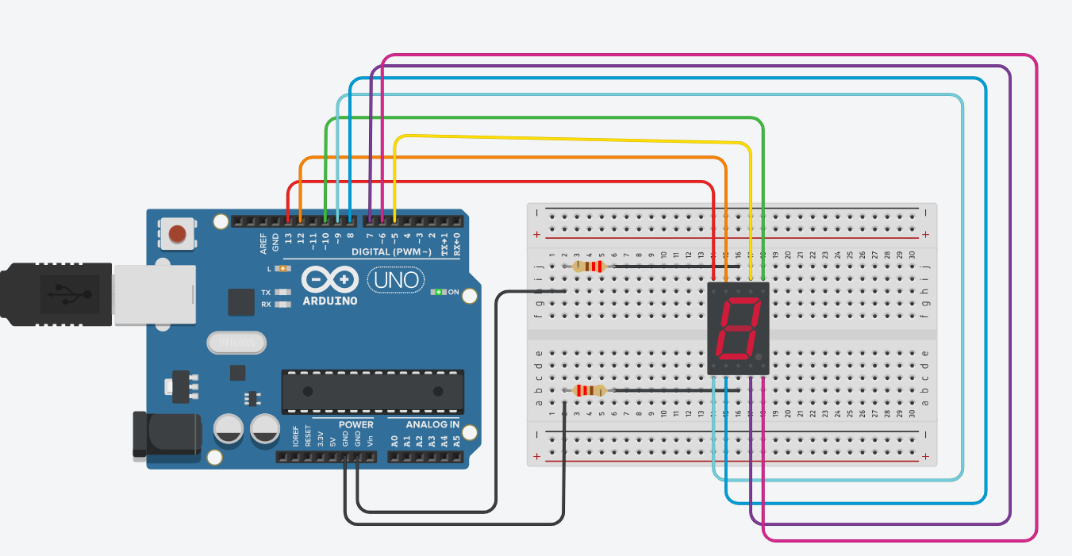

**Code:**

unsigned const int A=13;

unsigned const int B=12;

unsigned const int C=5;

unsigned const int D=10;

unsigned const int E=9;

unsigned const int F=8;

unsigned const int G=7;

unsigned const int H=6;

void setup(void)

{

pinMode(13,OUTPUT);

pinMode(12,OUTPUT);

pinMode(5,OUTPUT);

pinMode(10,OUTPUT);

pinMode(9,OUTPUT);

pinMode(8,OUTPUT);

pinMode(7,OUTPUT);

pinMode(6,OUTPUT);

}

void zero(void)

{

digitalWrite(A,HIGH);

digitalWrite(B,HIGH);

digitalWrite(C,HIGH);

digitalWrite(D,HIGH);

digitalWrite(E,HIGH);

digitalWrite(F,HIGH);

digitalWrite(G,HIGH);

digitalWrite(H,LOW);

}

void loop()

{

zero();

delay(1000);

}

**Program 2:**

**Aim:** To interface Seven Segment Display (SSD) with Arduino and write a program to  
print numbers from 1 to 9 on SSD.

**Objective of the program:** Blinking of seven segment display using Arduino circuit.

**Circuit design of program:**

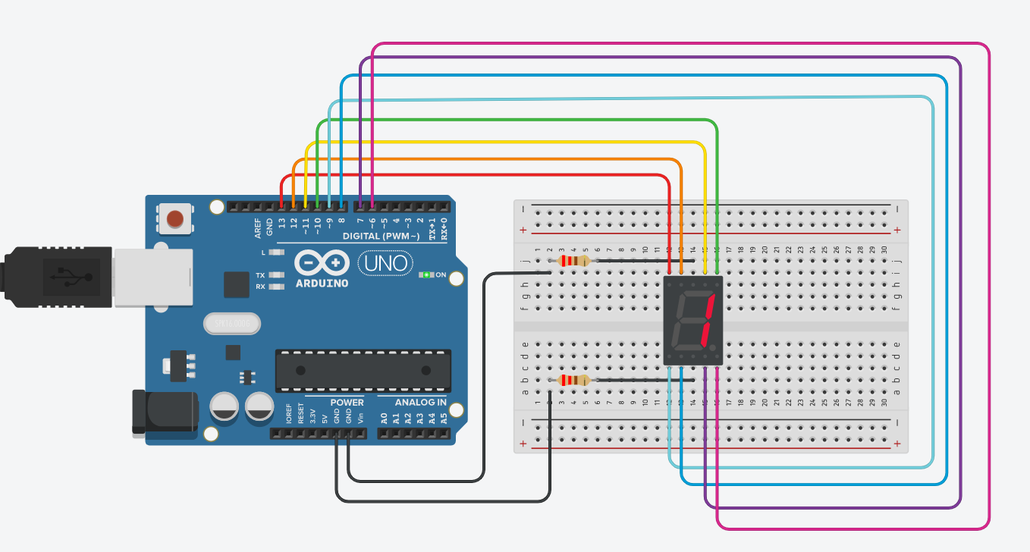

**Code:**

unsigned const int A=13;

unsigned const int B=12;

unsigned const int C=11;

unsigned const int D=10;

unsigned const int E=9;

unsigned const int F=8;

unsigned const int G=7;

unsigned const int H=6;

void setup(void)

{

pinMode(A,OUTPUT);

pinMode(B,OUTPUT);

pinMode(C,OUTPUT);

pinMode(D,OUTPUT);

pinMode(E,OUTPUT);

pinMode(F,OUTPUT);

pinMode(G,OUTPUT);

pinMode(H,OUTPUT);

}

void zero(void)

{

digitalWrite(A,HIGH);

digitalWrite(B,HIGH);

digitalWrite(C,HIGH);

digitalWrite(D,HIGH);

digitalWrite(E,HIGH);

digitalWrite(F,HIGH);

digitalWrite(G,HIGH);

digitalWrite(H,HIGH);

}

void one(void)

{

digitalWrite(A,LOW);

digitalWrite(B,LOW);

digitalWrite(C,LOW);

digitalWrite(D,HIGH);

digitalWrite(E,LOW);

digitalWrite(F,LOW);

digitalWrite(G,HIGH);

digitalWrite(H,LOW);

}

void two(void)

{

digitalWrite(A,HIGH);

digitalWrite(B,LOW);

digitalWrite(C,HIGH);

digitalWrite(D,HIGH);

digitalWrite(E,HIGH);

digitalWrite(F,HIGH);

digitalWrite(G,LOW);

digitalWrite(H,LOW);

}

void three(void)

{

digitalWrite(C,HIGH);

digitalWrite(D,HIGH);

digitalWrite(A,HIGH);

digitalWrite(G,HIGH);

digitalWrite(F,HIGH);

digitalWrite(B,LOW);

digitalWrite(E,LOW);

digitalWrite(H,LOW);

}

void four(void)

{

digitalWrite(A,HIGH);

digitalWrite(B,HIGH);

digitalWrite(C,LOW);

digitalWrite(D,HIGH);

digitalWrite(E,LOW);

digitalWrite(F,LOW);

digitalWrite(G,HIGH);

digitalWrite(H,LOW);

}

void five(void)

{

digitalWrite(A,HIGH);

digitalWrite(B,HIGH);

digitalWrite(C,HIGH);

digitalWrite(D,LOW);

digitalWrite(E,LOW);

digitalWrite(F,HIGH);

digitalWrite(G,HIGH);

digitalWrite(H,LOW);

}

void six(void)

{

digitalWrite(A,HIGH);

digitalWrite(B,HIGH);

digitalWrite(C,HIGH);

digitalWrite(D,LOW);

digitalWrite(E,HIGH);

digitalWrite(F,HIGH);

digitalWrite(G,HIGH);

digitalWrite(H,LOW);

}

void seven(void)

{

digitalWrite(A,LOW);

digitalWrite(B,LOW);

digitalWrite(C,HIGH);

digitalWrite(D,HIGH);

digitalWrite(E,LOW);

digitalWrite(F,LOW);

digitalWrite(G,HIGH);

digitalWrite(H,LOW);

}

void eight(void)

{

digitalWrite(A,HIGH);

digitalWrite(B,HIGH);

digitalWrite(C,HIGH);

digitalWrite(D,HIGH);

digitalWrite(E,HIGH);

digitalWrite(F,HIGH);

digitalWrite(G,HIGH);

digitalWrite(H,LOW);

}

void nine(void)

{

digitalWrite(A,HIGH);

digitalWrite(B,HIGH);

digitalWrite(C,HIGH);

digitalWrite(D,HIGH);

digitalWrite(E,LOW);

digitalWrite(F,HIGH);

digitalWrite(G,HIGH);

digitalWrite(H,LOW);

}

void loop()

{

zero();

delay(2000);

one();

delay(2000);

two();

delay(2000);

three();

delay(2000);

four();

delay(2000);

five();

delay(1000);

six();

delay(1000);

seven();

delay(1000);

eight();

delay(1000);

nine();

delay(1000);

}

**Practical No.7**

**Program 1:**

**Aim:** To interface LCD with Arduino and write a program to display message on LCD.

**Objective of the program:** Blinking of LCD with Arduino

**Circuit design of program:**

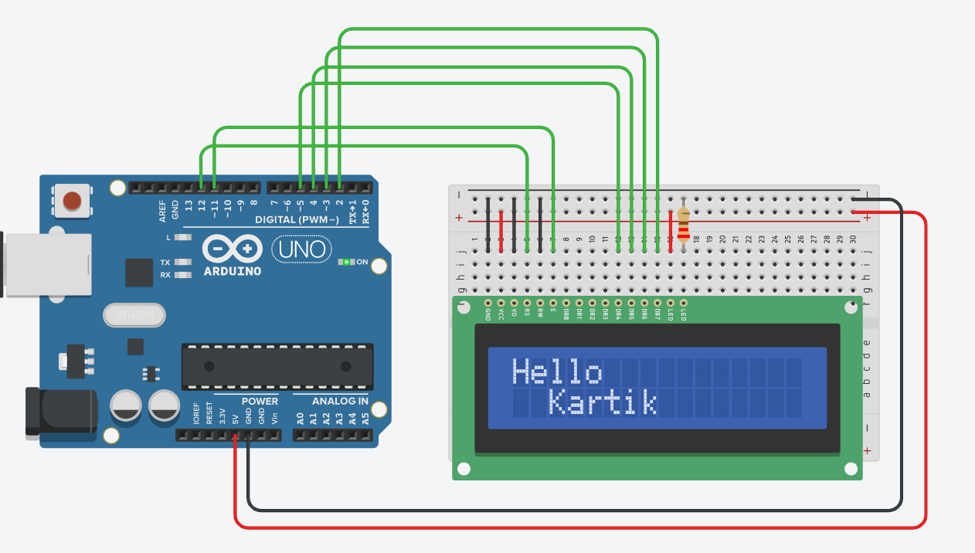

**Code:**

#include<LiquidCrystal.h>

LiquidCrystal lcd(12,11,5,4,3,2);

void setup()

{

lcd.begin(16,2);

}

void loop()

{

lcd.setCursor(0,0);

lcd.print("Hello");

lcd.setCursor(2,1);

lcd.print("Kartik");

}

/*LiquidCrystal(RS,E,D4,D5,D6,D7);

LiquidCrystal(RS,E,D4,D5,D6,12);

lcd.begin();

lcd.setCursor();

lcd.print("Hello Kartik");

lcd.noCursor();

lcd.Cursor();

lcd.blink();

lcd.display();

lcd.noDisplay();*/

**Program 2:**

**Aim:** To interface LCD, potentiometer with Arduino and write a program to  
display message on LCD.

**Objective of the program:** Blinking of LCD with Arduino using Potentiometer.

**Circuit design of program:**

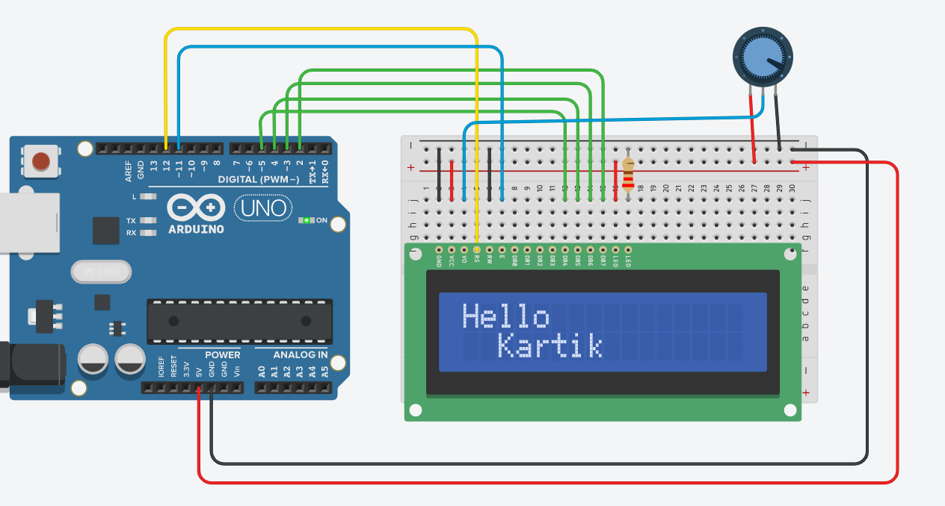

**Code:**

#include<LiquidCrystal.h>

LiquidCrystal lcd(12,11,5,4,3,2);

void setup()

{

lcd.begin(16,2);

}

void loop()

{

lcd.setCursor(0,0);

lcd.print("Hello");

lcd.setCursor(2,1);

lcd.print("Kartik");

}

**Program 3:**

**Aim:** To interface LCD,Push Button,potentiometer with Ardunio and write a program to print a message on LCD when push button is pressed.

**Objective of the program:** Blinking of LCD Display when puch buttonis pressed using aurdino circuit.

**Circuit design of program:**

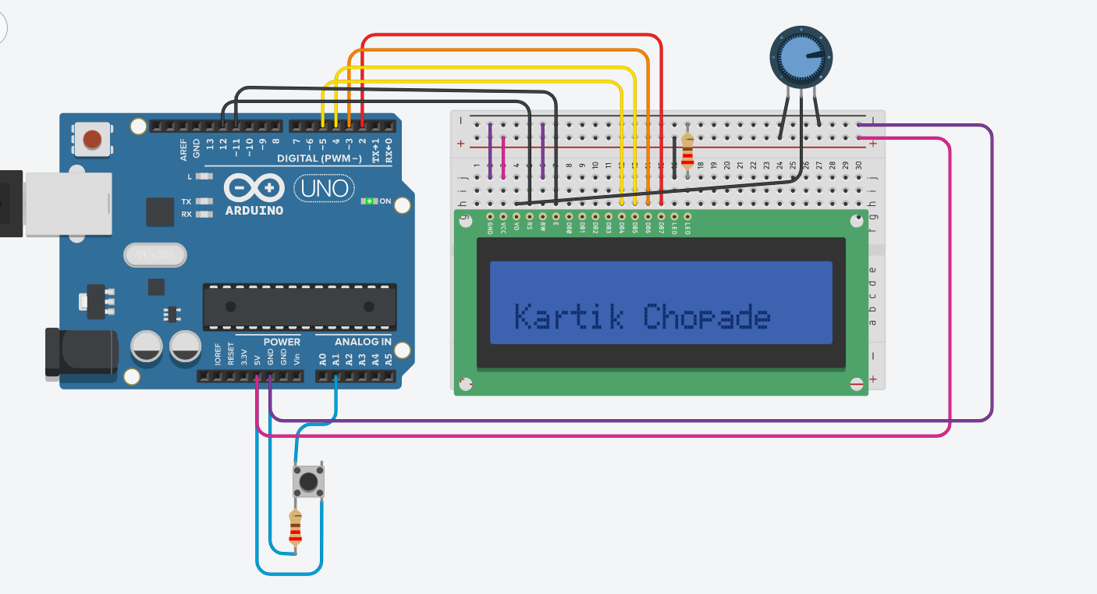

**Code:**

#include<LiquidCrystal.h>

LiquidCrystal lcd(12,11,5,4,3,2);

void setup()

{

lcd.begin(16,2);

pinMode(A1,INPUT);

}

void loop()

{

lcd.setCursor(0,1);

if(digitalRead(A1)==HIGH)

{

lcd.print("Kartik Chopade");

}

}

**Practical No.8**

**Program 1:**

**Aim:** To interface LCD, push button,potentiometer with Arduino and write a program to  
display the no. of times (count) the push button is pressed on LCD.

**Objective of the program:** Blinking of LCD using push button,potentiometer display the no. fo times the push button is pressed.

**Circuit design of program:**

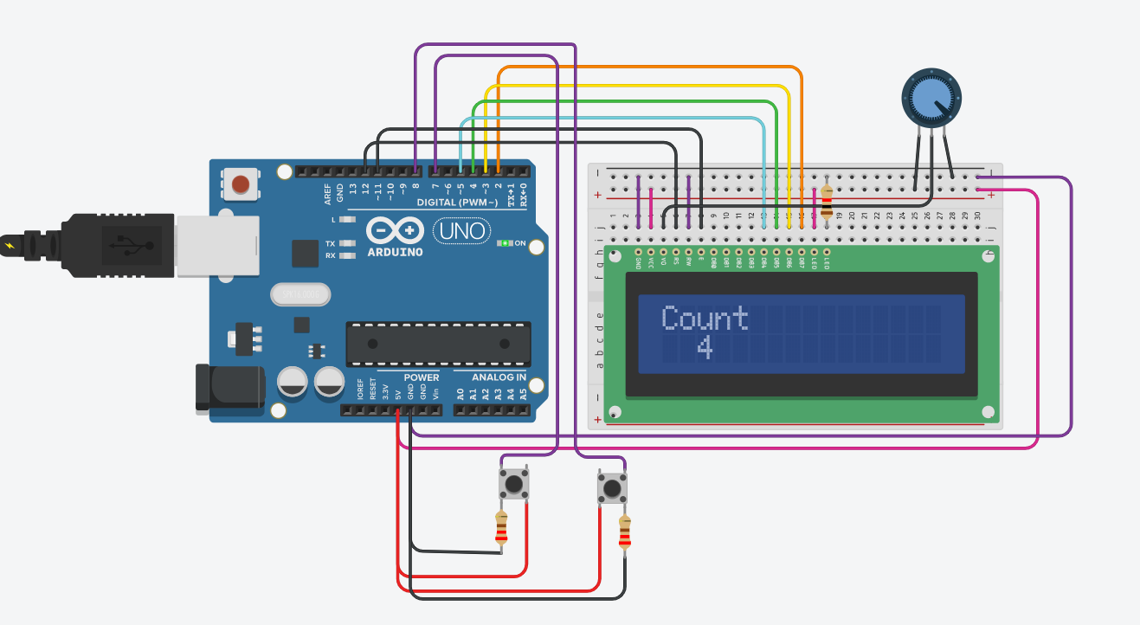

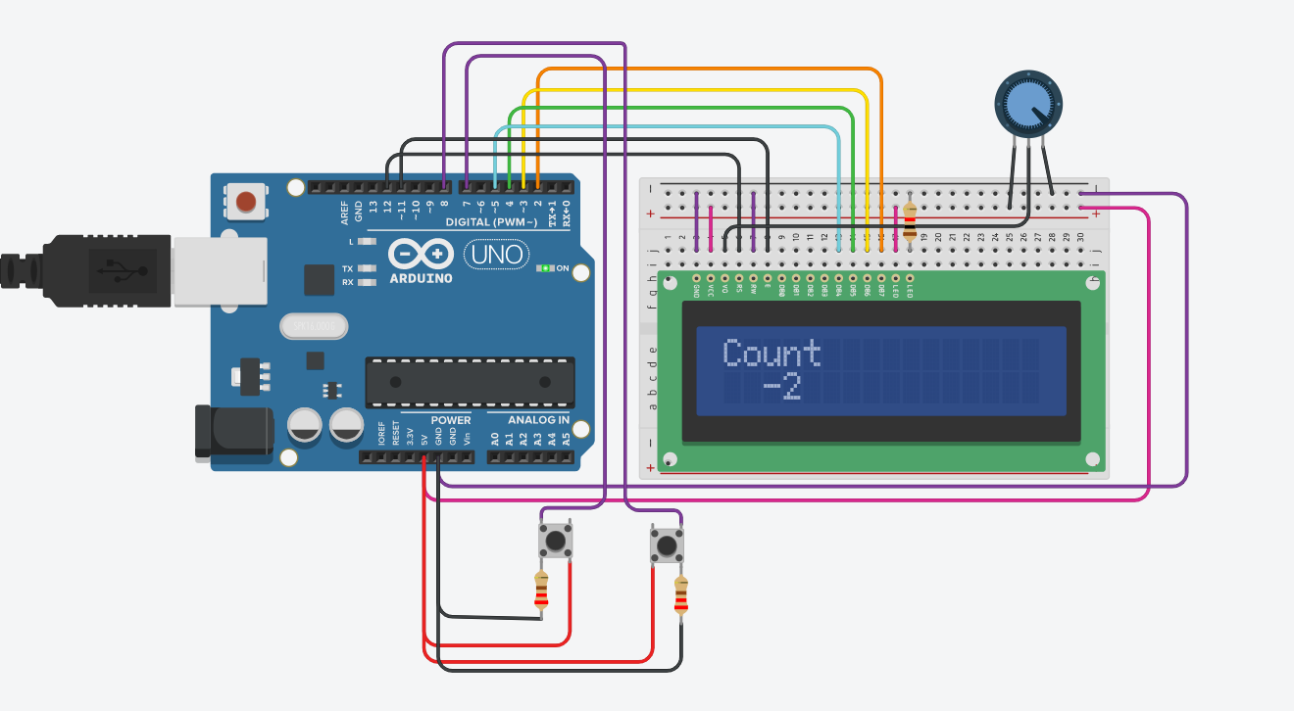

**Code :**

#include<LiquidCrystal.h>

int count=0;

int press;

LiquidCrystal lcd(12,11,5,4,3,2);

void setup()

{

lcd.begin(16,2);

pinMode(7,INPUT);

pinMode(8,INPUT);

}

void loop()

{

lcd.setCursor(0,0);

lcd.print("Count");

if(digitalRead(7)==1)

{

count=count+1;

press=count;

delay(250);

lcd.setCursor(2,1);

lcd.print(press);

}

else if(digitalRead(8)==1)

{

count=count-1;

press=count;

delay(250);

lcd.setCursor(2,1);

lcd.print(press);

}

}

**Practical No.9**

**Program 1:**

**Aim:** To interface LED, Photo resistor (LDR) with Arduino and write a program to increase and decrease the brightness of the LED based on the amount of light present.

**Objective of the program:** Blinking of LED using Aurduino to increase and decrease the brightness of the LED.

**Circuit design of program:**

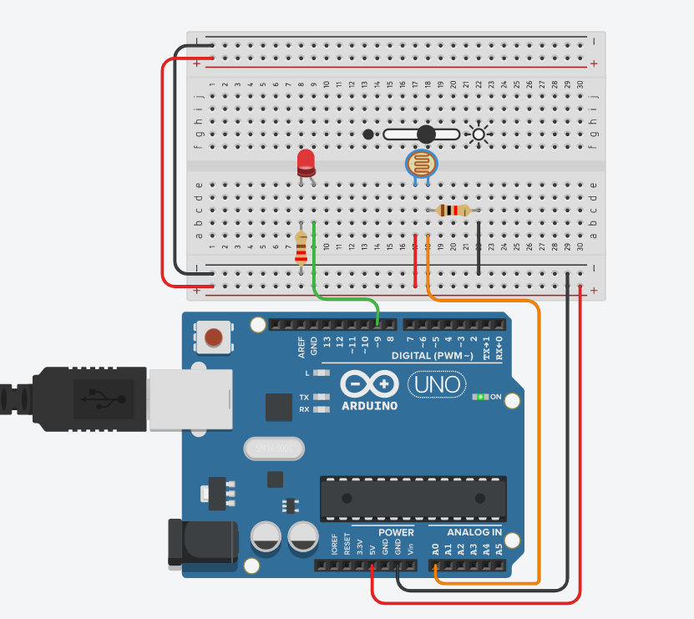

**Code:**

int photoensor = 0;

void setup()

{

pinMode(A0, INPUT);

Serial.begin(9600);

pinMode(9, OUTPUT);

}

void loop()

{

photoensor = analogRead(A0);

Serial.println(photoensor);

analogWrite(9, map(photoensor, 0, 1023, 0, 255));

delay(1000); // Wait for 1000 millisecond(s)

}

**Practical No.10**

**Program 1:**

**Aim:** To interface *DHT11* sensor with Arduino and write a program to display temperature and humidity data on serial monitor.

**Objective of the program:** to display temperature and humidity data on serial monitor. **Circuit design of program:**

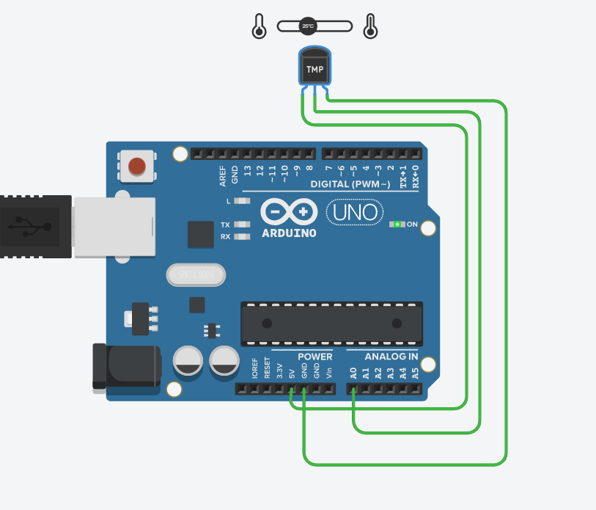

**Code:**

void setup()

{

Serial.begin(9600);

}

void loop()

{

int sensorValue=analogRead(A0);

float volt=(sensorValue/1023.0)*4.9;

delay(1000);

float tempc=(volt-0.5)*100;

Serial.println(tempc);

delay(1000);

}

**Output:**

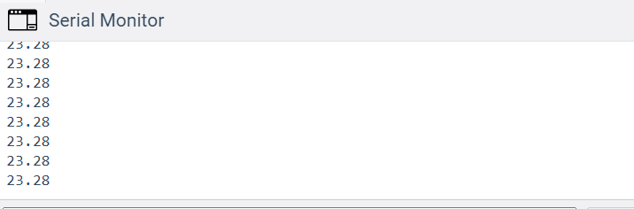

**Practical No.14**

**Program 1:**

**Aim:** To interface PIR/ Ultrasonic sensor with Arduino and write a program to turn on and off LED depending on motion detection/sound detection.

**Objective of the program:** to turn on and off LED depending on motion detection/sound detection. Using PIR Sensor.

**Circuit design of program:**

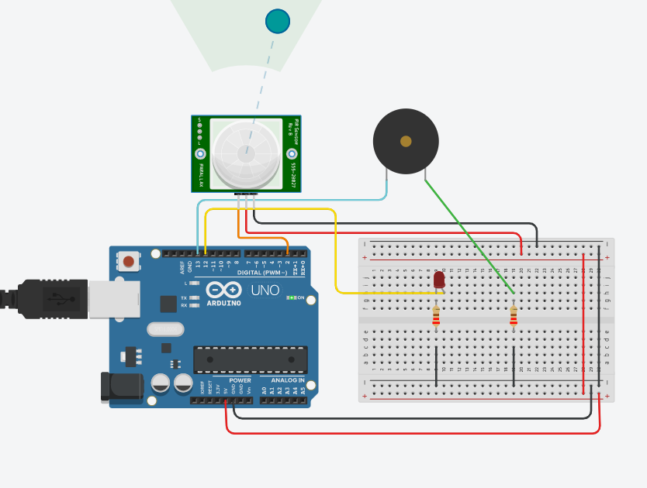

**Code :**

int pinSensor=2;

int pinLed=12;

int pinBuzzer=13;

int pirSensor=0;

void setup()

{

pinMode(pinSensor,INPUT);

pinMode(pinLed,OUTPUT);

pinMode(pinBuzzer,OUTPUT);

}

void loop()

{

pirSensor=digitalRead(pinSensor);

if(pirSensor==HIGH)

{

digitalWrite(pinLed,HIGH);

tone(pinBuzzer,1000,500);

}

else

{

digitalWrite(pinLed,LOW);

}

delay(10);

}

**Practical No.15**

**Program 1:**

**Aim:** To interface servo motor/DC motor with Arduino and write a program to sweep a servo back and forth through its full range of motion/ to control a DC motor.

**Objective of the program:** program to sweep a servo back and forth through its full range of motion/ to control a DC motor.

**Circuit design of program:**

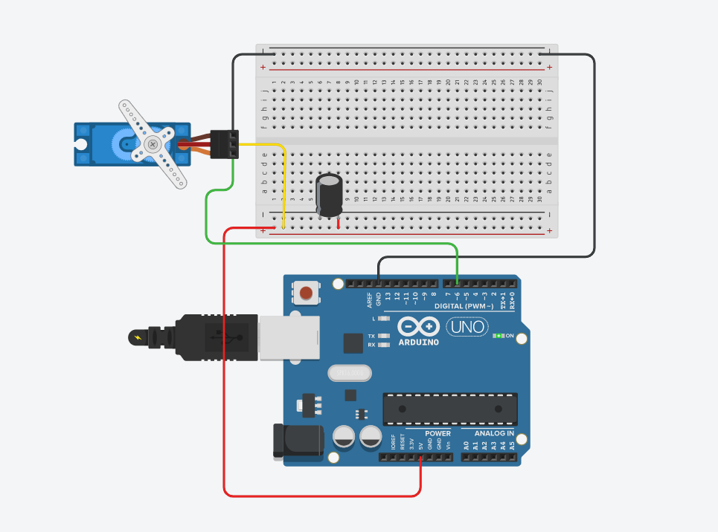

**Code :**

#include <Servo.h>

Servo myservo;

void setup()

{

myservo.attach(6);

}

void loop()

{

for(int ang=0;ang<180;ang++)

{

myservo.write(ang);

delay(10);

}

for(int ang=180;ang>0;ang--)

{

myservo.write(ang);

delay(10);

}

}

**Practical No.16**

**Program 1:**

**Aim:** To Interface Speed Control of DC motor.

**Objective of the program:** Speed Control of DC motor using Arduino circuit.

**Circuit design of program:**

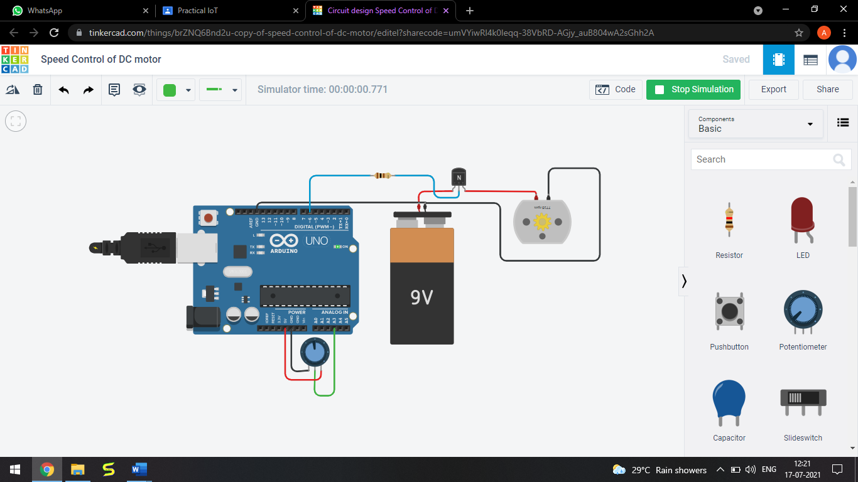

**Code :**

const int poten = A3;

int var;

void setup()

{

Serial.begin(9600);

pinMode(6, OUTPUT);

}

void loop()

{

var = analogRead(poten);

analogWrite(6,var);

Serial.println(var);

}